Style Guidelines for Final Year Project ReportsStudent’s Facilitator

Final Year Project Proposal

Session 2016-2020

A 4th Year StudentA 4th Year Student

A project submitted in partial fulfilment of the

COMSATS University Degree

of

BSc. (Hons.)BS in Computer Science / Software Engineering (CUI)



Submitted by

Ayishm Azeem FA16-BCS-054

Ahmad Hassan Minhas FA16-BCS-232

Department of Computer Science

COMSATS University Islamabad, Lahore Campus

27 September 2019

**Project Registration**

|  |  |  |  |  |  |  |  |
| --- | --- | --- | --- | --- | --- | --- | --- |
| Project ID (for office use) | | |  | | | | |
| Type (Nature of project) | | | [ ] **D**evelopment [ ] **R**esearch [ ] **R**&**D** | | | | |
| Area of specialization | | |  | | | | |
| **Project Group Members** | | | | | | | |
| Sr.# | Reg. # | Student Name | | CGPA | Email ID | Phone # | Signature |
| (i) | FA16-BCS-054 | Ayishm Azeem | | 2.49 | [Ayishm96@gmail.com](mailto:Ayishm96@gmail.com) | 0304-3384456 |  |
| (ii) | FA16-BCS-232 | Ahmad Hassan Minhas | | 2.49 | ahmadhassanminnhas@gmail.com | 0302-8787966 |  |
| (iii) |  |  | |  |  |  |  |
| Name & Signature of Batch Advisor  (If students are eligible for FYP) | | | |  | | | |

# Plagiarism Free Certificate

This is to certify that, I am ________________________ S/D/o _______________________, group leader of FYP under registration no CIIT/_________________/LHR at Computer Science Department, COMSATS Institute of Information Technology, Lahore. I declare that my FYP proposal is checked by my supervisor and the similarity index is ________% that is less than 20%, an acceptable limit by HEC. Report is attached herewith as Appendix A.

Date: ____________ Name of Group Leader: ________________________ Signature: _____________

Name of Supervisor: _____________________ Co-Supervisor (if any):____________________

Designation: _____________________ Designation: _____________________

Signature: _____________________ Signature: _____________________

**Approval of FYP Management Committee**

Committee Member 1: Name: _____________________

[ ] Accept [ ] *Defer [ ] *Reject Signature: _______________

*Remarks: _____________________________________________________________________

Committee Member 2: Name: _____________________

[ ] Accept [ ] *Defer [ ] *Reject Signature: _______________

*Remarks: _____________________________________________________________________

Convener: Name: _____________________

[ ] Accept [ ] *Defer [ ] *Reject Signature: _______________

*Remarks: _____________________________________________________________________

**Project Abstract**

We're fortunate to be living in a time where science and technology can assist us in our lives. The technology we're accustomed to has facilitated us to innovate further, and save both, time and energy to accomplish our everyday tasks.  
Student facilitator will be an android application that will help University students to socialize, learn, earn and become familiar with their environment, after signing in.

This application will provide a platform for resource sharing and services to students. It will facilitate them with sharing of semester notes, help them to earn through the feature of providing transportation services (carpooling) and by sharing rooms with university students. It will solve the predicaments students face everyday thus providing them with lacuna for amelioration. Not only thats but other features like, FYP partners, ideas and assistants, consultancy and a forum for discussion will serve as a ladder to help students overcome the challenges they face everyday and will undoubtedly facilitate excellence.

This application will be tested in our own campus and will further be deployed in areas in demand of this facility. This software is bound to be a major hit for students all over the country, no matter what field they belong to.

**Introduction**

Student facilitator is an application that will be implemented to make student life a bit easier. Our project aims at lessening the gap between students and overcome issues that they face in their student life. It will be designed to establish better communication among students. The students will be at receiving end with toppers serving as the benefactors, providing the relevant guidelines and notes related to the courses and everyone else being helpful to each other by sharing their ideas, experiences and personal resources. Introducing such kind of applications for the university students will help students in very effective way.

**Motivation and Scope**

Human beings are becoming more and more dependent on technology, they require solution to every problem on their handy devices. So keeping that in mind we have brought out a solution package for University students, and that is actually going to work as their assistant. This application will be free to use, it will include free and paid services. Carpooling will be its most attractive feature that will help students to share their rides with University members, and earn through it. Students having this application won’t have to request or seek for help from their friends only. They will find the whole campus for their help. It will have the option of reporting the users found misconducting or violating rules of the platform,no use of pictures or video uploads will be allowed in any section of the application**,** except the notes section. This will keep the users safe from irrelevant or unauthentic content. In all terms it will be an ultimate facilitator.

**Related Work**

There isn’t any app that is providing all those features collectively as we will be offering in our mobile application. Following are the few applications that facilitate users by providing individual services.

CuOnline is a web based portal that provides transaction, administrative and academic records.

<https://sfs.cuilahore.edu.pk/SFS/sfs.aspx> SFS of our own campus is facilitating students, regarding their accounts and query sections, it is saving their time and energy.

Savaree is a carpooling application that connects passengers with the drivers taking the desired route as of the passengers.

We are willing to provide students with all those services that they require in their daily life, on the same platform.

**Goals and Objectives**

Students will have to sign up in the application to get access to the following features of the application.

**Notes sharing**

Students with good notes will get an opportunity to upload their notes on an application which will later become useful for everyone in university. This section will contain a category of departments which will be having notes arranged according to the semesters and their subjects.

**Carpooling**

Some students cannot afford public transportation, so students taking the same route as the other has to travel, can charge accordingly to make that person reach his destination on cheap rates. It will provide the details of a driver, his car, route, vacant seats and fare charges. Fare will be paid through cash. The records of rides taken by a person will be maintained in that person’s account.

**Discussion forum**

On this forum students will be able to communicate anonymously, and will share their personal details on their own will. This Forum will facilitate students through answers to the queries made by students. The discussion will only be limited to FYP consultancy, rating of courses, and the general tips for students that will help them to succeed.

**Hostels**

Information regarding hostels near university will be provided including their location, fees and facilities. Also, students who seek new roommates will be able to post adds about their room condition and other information regarding a vacant spot through this platform.

**Tutor**

Some students find difficulty in grabbing concepts, or studying the syllabus content. For that, students interested in teaching courses or subjects can sign in the portal to publicize themselves as a tutor*.*

**Gantt Chart**

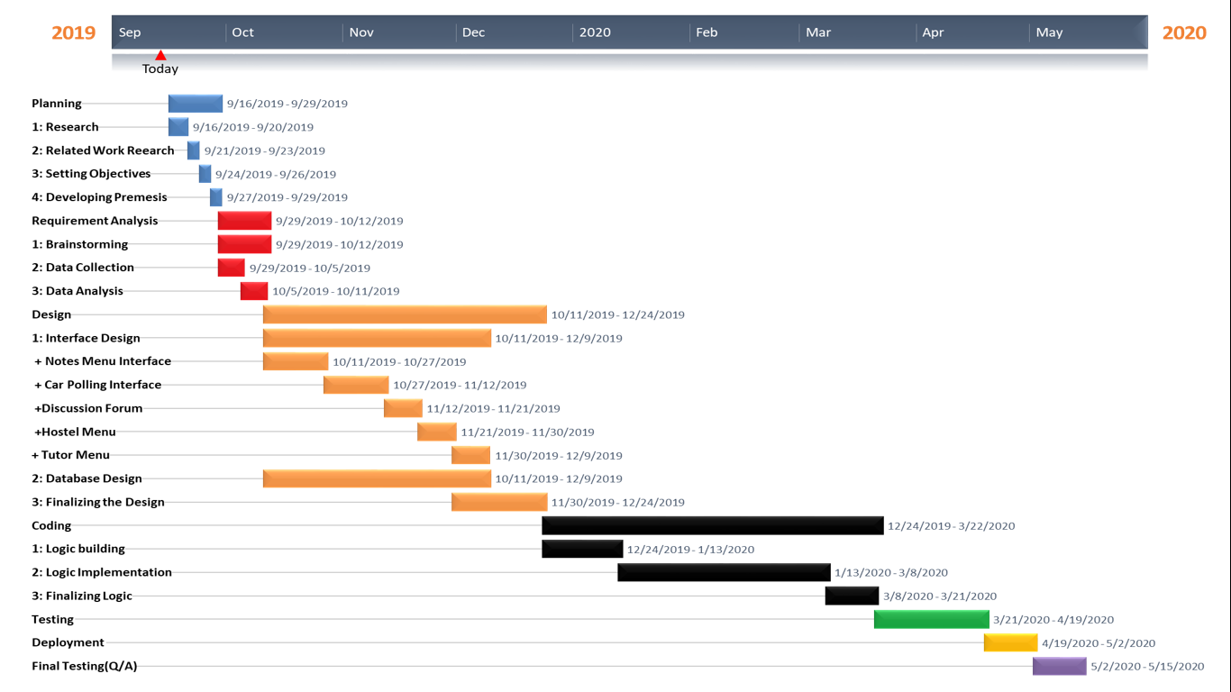

**Tools and Technologies**

|  |  |  |
| --- | --- | --- |
| **Title** | **Tools** | **Technologies** |
| Front End | React Native | VS Code |
| Back End | Python | Pycharm |
| Database | MySQL or Mongodb | MYSQL or MongoDB |

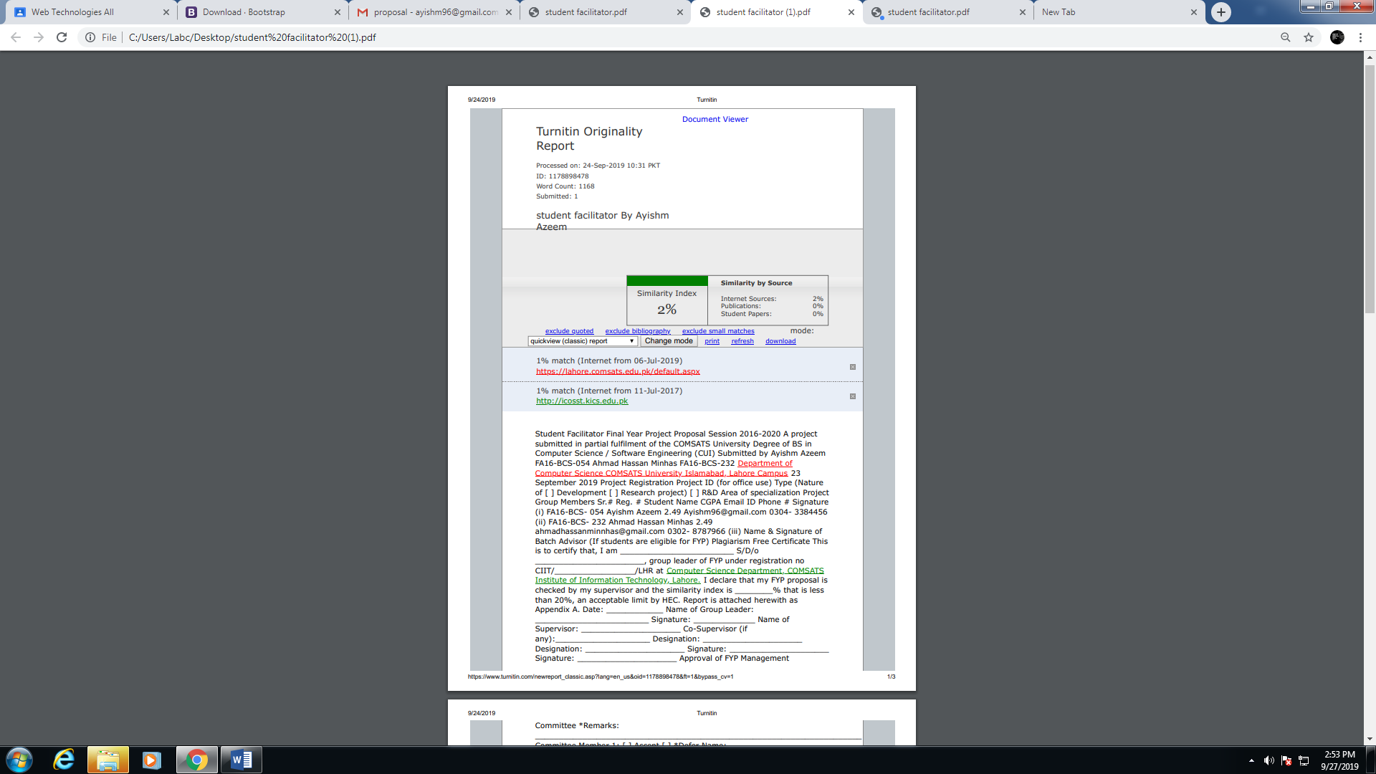*77*